
Holy Cross College

Semester 1 Examination 2015

Multiple Choice Booklet

Year 10 Science
Please place your student identification label in this box
(Adjusted)

Student Name
Student’s Teacher

Time allowed for this paper

Reading time before commencing work: 5 minutes
Working time for paper: 50 minutes

Materials required/recommended for this paper

To be provided by the supervisor

This Question/Answer Booklet
Data Sheet

To be provided by the candidate

Standard items: pens, pencils, eraser, correction fluid, ruler, highlighters.
Special items: non-programmable calculators satisfying the conditions set by the School Curriculum and Standards Authority for this course.

Important note to candidates

No other items may be taken into the examination room. It is your responsibility to ensure that you do not have any unauthorised notes or other items of a non-personal nature in the examination room. If you have any unauthorised material with you, hand it to the supervisor before reading any further.
SECTION 1 MULTIPLE CHOICE (26 marks)

Make a choice of answer and mark it with a cross on the answer sheet in the answer booklet.

1 . The alternative forms of each gene are called:

(a) alleles.
(b) gametes.
(c) hybrids.
(d) monohybrids.

2. In pea plants, the gene for tall stems (T) is dominant over the gene for short stems (t). The phenotype for a pea with the gene combination Tt is:

(a) tall stems.
(b) middle-size stems.
(c) short stems.
(d) TT.

3. When red flowered snapdragons are crossed with white flowered snapdragons, some of the offspring have pink flowers. This is an example of:

(a) cloning.
(b) incomplete dominance.
(c) co-dominance.
(d) mutation.

4. An organism is heterozygous for a characteristic if it has:

(a) two genes that are the same.
(b) more than two genes that are the same.
(c) only one gene.
(d) two different genes.

5. Which process causes changes in chromosomes to occur?

(a) Cell division.
(b) Mutations.
(c) Gene replication.
(d) Reproduction.

6. Dogs have 28 chromosomes in their skin cells. How many chromosomes does a haploid dog cell contain?

(a) 14
(b) 28
(c) 1
(d) 56
The next two questions relate to the information below.

The following punnett square shows the likely result of breeding two heterozygous black guinea pigs. The guinea pigs black colour gene (B) dominates the brown colour gene (b).

 | B | b
B | BB | Bb
b | Bb | ?

7. The genotype of the offspring in the incomplete square is:

(a) bb.
(b) Bb.
(c) BB.
(d) brown.

8. The phenotype of the offspring in the incomplete square would be:

(a) black.
(b) black and brown.
(c) black and white.
(d) brown.

9. DNA stands for:

(a) dinucleotide acid.
(b) ribonucleic acid.
(c) deoxyribonucleic acid.
(d) dioxyriboncleus acid.

10. Dominant genes mask the presence of _____ genes.

(a) heterozygous
(b) pure-bred
(c) recessive
(d) homozygous

11. The primary purpose of meiosis is:

(a) to produce new skin cells.
(b) to produce gametes.
(c) for growth and repair.
(d) for DNA replication.

12. Let us say that the gene that codes for normal-type wings in fruit flies has the symbol ‘N’ and the gene that codes for vestigial (stunted) wings has the symbol ‘n’. The genotype of heterozygous flies would be:

(a) Nn.
(b) normal wings.
(c) NN.
(d) nn.

13. What term means the same as ‘pure-breeding’?

(a) Heterozygous
(b) Homozygous
(c) Hybrid
(d) Dominant

14. Where in the cell are chromosomes located?

(a) In the cytosol.
(b) In the nucleus.
(c) In the vacuoles.
(d) In the cell membrane.

15. The following pedigree shows the occurrence of colour blindness in three generations of a
family.

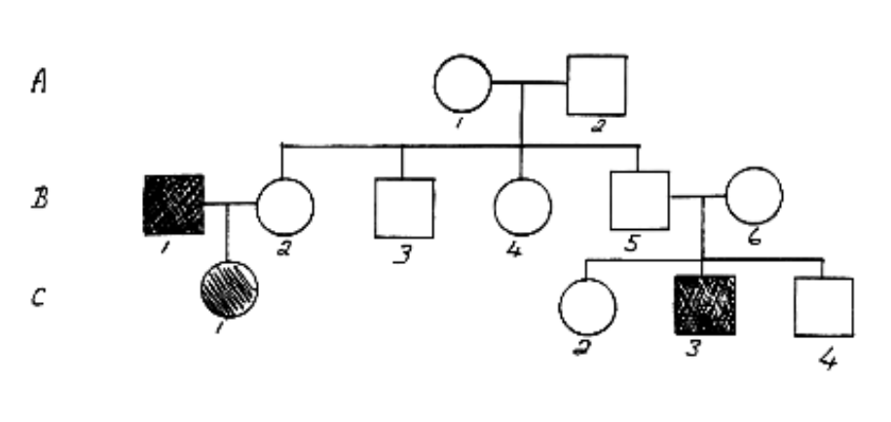

From the above family tree it can be concluded:

(a) B1 has normal vision.
(b) A2 has colour blindness.
(c) C3 is colour blind.
(d) C1 has normal vision.

16. What is a black hole?

(a) A rapidly spinning star that gives out neutrons.
(b) A dark invisible hole in space that is a worm hole into another parallel universe.
(c) A massive explosion that gives out huge amounts of light.
(d) The remains of a star that is so massive that light can not escape from it.

17. What are galaxies? Select the best answer from the options below.

(a) Huge masses of gas that explode.
(b) Collections of stars and solar systems and gas clouds.
(c) Shining objects in the sky.
(d) A star, along with its planets and their moons.

18. If the light from a star is red shifted, that tells us that:

(a) the star must be moving towards us.
(b) the star must be moving away from us.
(c) the star must be moving parallel to us.
(d) the star must have a solar system of planets.

19. The Universe is expanding. This is usually taken to be evidence that:

(a) the universe began in a Big Bang.
(b) we are at the centre of the Universe.
(c) gravity only works near the Earth.
(d) the universe was created by a Supreme Being.

20. A light year is defined as:

(a) the distance light travels from the closest star.
(b) the distance from Alpha Centauri to the sun.
(c) the distance of the Earth from the sun.
(d) the distance light travels in a year.

21. The main fuel of stars is:

(a) hydrogen.
(b) helium.
(c) carbon.
(d) gold.

22. A galaxy is a group of many billions of stars held together by _____.

(a) gravitational forces.
(b) black holes.
(c) magnetic forces.
(d) quasars.

23. The Milky Way is most accurately described as a _____.

(a) planet.
(b) universe.
(c) solar system.
(d) galaxy.

24. What type of reaction fuels the vast amount of energy produced by a star?

(a) Nuclear fission
(b) Chemical
(c) Physical
(d) Nuclear fusion

25. Which of the following is the best definition of a constellation?

(a) A grouping of planets in an apparent pattern.
(b) Patterns of stars that change.
(c) Stars that are in fixed positions together.
(d) A grouping of stars in an apparent pattern.

26. How long ago was the Big Bang?

(a) 15 billion years ago
(b) 10 trillion years ago
(c) 1 billion years ago
(d) 65 million years ago

END OF SECTION 1

